**Mehran University of Engineering and Technology**

**MILKSHOP**

**MANAGEMENT SYSTEMS**

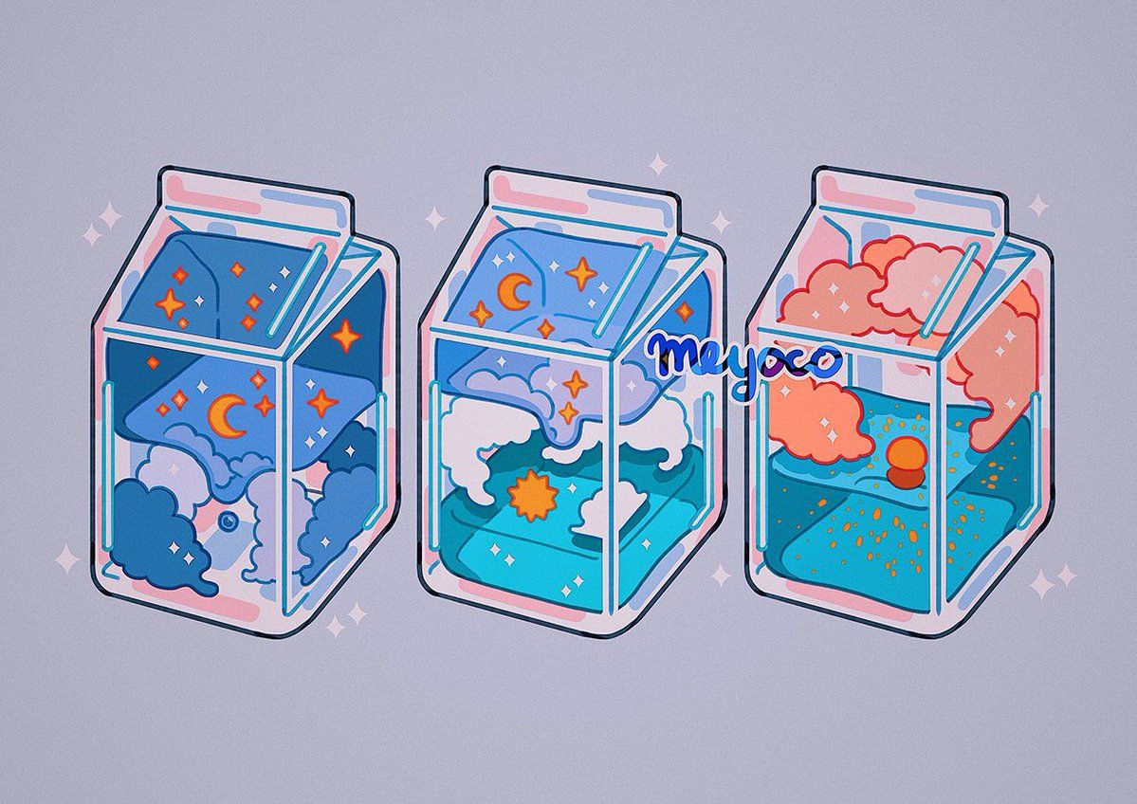

**2**

**0**

**2**

**2**

**Adeena Tariq (20CS068)**

**Ansa Fatima (20CS048)**

**Insharah Sultana (20CS028)**

**Submitted to:**

**Sir Jamsher**

**Certificate of Approval**

*The undersigned certify that they have read and recommended to the Department of Computer Systems for acceptance, a project report entitled “THE MILK SHOP” submitted by:*

1. *Adeena Tariq(20CS68)*
2. *Ansa Fatima(20CS48)*
3. *Insharah Sultana (20CS028)*

*in partial fulfillment of the requirement for the Project of Computer Graphics of the Third semester of Bachelor of Computer Systems.*

# TABLE OF CONTENTS

|  |
| --- |
| Introduction |
| Components Of Java |
| Objectives |
| Source Code |
| Output |
| SNAPSHOTS |
| Requirements |
| Conclusion |

# INTRODUCTION

The mission of the Milk Production House Project is to create to communication between rural area people and dairy management. Our main goal to develop this application to encourage a dairy industry. MILKSHOP MANAGEMENT SYSTEM is a software application to maintain day to day transactions in a Milk Distributor Office. This software helps to register all the details, purchase, Sales and remaining amount milk details etc., The project entitled MILKSHOP MANAGEMENT SYSTEM is a pilot project for new Milk Distributor to be start soon in the city. The management planned this Milk Distribution center to operate. To manage all these, they require a full-fledged software which will take care all these.

# COMPONENTS OF JAVA

we have worked on Project Milk shop, by adding different functions we have created management of milk shop using java swing, AWT and Layout by which we can easily handle with hundreds of thousands records in shop. It reduces the manual work and saves time.

* **Java swings:**

Java Swing is a lightweight Java graphical user interface (GUI) widget toolkit that includes a rich set of widgets. It is part of the Java Foundation Classes (JFC) and includes several packages for developing rich desktop applications in Java. Swing includes built-in controls such as trees, image buttons, tabbed panes, sliders, toolbars, colour choosers, tables, and text areas to display HTTP or rich text format (RTF). Swing components are written entirely in Java and thus are platform independent.

* **AWT:**
* **Java AWT** (Abstract Window Toolkit) is an API to develop Graphical User Interface (GUI) or windows-based applications in Java.
* Java AWT components are platform-dependent i.e. components are displayed according to the view of operating system. AWT is heavy weight i.e. its components are using the resources of underlying operating system (OS).
* The java.awt [package](https://www.javatpoint.com/package) provides [classes](https://www.javatpoint.com/object-and-class-in-java) for AWT API such as [Text Field](https://www.javatpoint.com/java-awt-textfield), [Label](https://www.javatpoint.com/java-awt-label), [TextArea](https://www.javatpoint.com/java-awt-textarea), Radio Button, Checkbox, [Choice](https://www.javatpoint.com/java-awt-choice), [List](https://www.javatpoint.com/java-awt-list) etc.
* **Layout:**

The layout Managers are used to arrange components in a particular manner. The Java Layout Managers facilitates us to control the positioning and size of the components in GUI forms. Layout Manager is an interface that is implemented by all the classes of layout managers.

# OBJECTIVES

**Objectives of Milk shop Management System:**

The main objective of this program is to automate the complete operations of the milk Distributors office and bring ease between each milk shop’s managers and the system admin. They need to maintain hundreds of thousands of records.

# SOURCE CODE

import java.awt.BorderLayout;

import java.awt.EventQueue;

import javax.swing.JFrame;

import javax.swing.JPanel;

import javax.swing.border.EmptyBorder;

import javax.swing.JLabel;

import javax.swing.JOptionPane;

import java.awt.Font;

import javax.swing.SwingConstants;

import javax.swing.JTextField;

import javax.swing.JButton;

import java.awt.event.ActionListener;

import java.awt.event.ActionEvent;

import java.awt.Color;

import javax.swing.ImageIcon;

public class MilkSHop extends JFrame {

double ppl=1.00;

double tamt = 0;

double rem;

private JPanel contentPane;

private JTextField tF1;

private JTextField tF2;

private JLabel lbl1;

private JLabel lbl2;

private JLabel lbl3;

/**

* Launch the application.

*/

public static void main(String[] args) {

EventQueue.invokeLater(new Runnable() {

public void run() {

try {

MilkSHop frame = new MilkSHop();

frame.setVisible(true);

} catch (Exception e) {

e.printStackTrace();

}

}

});

}

/**

* Create the frame.

*/

public MilkSHop() {

setDefaultCloseOperation(JFrame.EXIT_ON_CLOSE);

setBounds(100, 100, 471, 434);

contentPane = new JPanel();

contentPane.setBorder(new EmptyBorder(5, 5, 5, 5));

setContentPane(contentPane);

contentPane.setLayout(null);

JLabel lblNewLabel = new JLabel("RS Milk Shop");

lblNewLabel.setHorizontalAlignment(SwingConstants.CENTER);

lblNewLabel.setFont(new Font("Times New Roman", Font.BOLD, 35));

lblNewLabel.setBounds(91, 23, 281, 52);

contentPane.add(lblNewLabel);

JLabel lblNewLabel_1 = new JLabel("Total Milk:");

lblNewLabel_1.setFont(new Font("Tahoma", Font.BOLD, 19));

lblNewLabel_1.setBounds(67, 109, 138, 23);

contentPane.add(lblNewLabel_1);

tF1 = new JTextField();

tF1.setBounds(245, 112, 138, 20);

contentPane.add(tF1);

tF1.setColumns(10);

JLabel lblNewLabel_2 = new JLabel("Milk Purchased:");

lblNewLabel_2.setFont(new Font("Tahoma", Font.BOLD, 19));

lblNewLabel_2.setBounds(67, 154, 168, 20);

contentPane.add(lblNewLabel_2);

tF2 = new JTextField();

tF2.setColumns(10);

tF2.setBounds(245, 154, 138, 20);

contentPane.add(tF2);

JLabel lblNewLabel_2_2 = new JLabel("Remaining Milk:");

lblNewLabel_2_2.setFont(new Font("Times New Roman", Font.BOLD, 18));

lblNewLabel_2_2.setBounds(96, 272, 160, 20);

contentPane.add(lblNewLabel_2_2);

JLabel lblNewLabel_2_2_1 = new JLabel("Amount:");

lblNewLabel_2_2_1.setFont(new Font("Times New Roman", Font.BOLD, 18));

lblNewLabel_2_2_1.setBounds(96, 238, 128, 20);

contentPane.add(lblNewLabel_2_2_1);

JLabel lblNewLabel_2_2_2 = new JLabel("Total Amount:");

lblNewLabel_2_2_2.setFont(new Font("Times New Roman", Font.BOLD, 18));

lblNewLabel_2_2_2.setBounds(96, 303, 128, 20);

contentPane.add(lblNewLabel_2_2_2);

JLabel lbl3 = new JLabel("$0.0");

lbl3.setHorizontalAlignment(SwingConstants.CENTER);

lbl3.setFont(new Font("Times New Roman", Font.BOLD, 18));

lbl3.setBounds(244, 303, 128, 20);

contentPane.add(lbl3);

Label lbl1 = new JLabel("$0.0");

lbl1.setHorizontalAlignment(SwingConstants.CENTER);

lbl1.setFont(new Font("Times New Roman", Font.BOLD, 18));

lbl1.setBounds(244, 242, 128, 20);

contentPane.add(lbl1);

JLabel lbl2 = new JLabel("0.0L");

lbl2.setHorizontalAlignment(SwingConstants.CENTER);

lbl2.setFont(new Font("Times New Roman", Font.BOLD, 18));

lbl2.setBounds(244, 272, 128, 20);

contentPane.add(lbl2);

JButton btnNewButton = new JButton("\u2714");

btnNewButton.addActionListener(new ActionListener() {

public void actionPerformed(ActionEvent e) {

double tMilk = Double.parseDouble(tF1.getText());

double milk2 = Double.parseDouble(tF2.getText());

if (tMilk>0) {

double amt = milk2*ppl;

lbl1.setText("$"+Double.toString(amt));

tamt +=amt;

lbl3.setText("$"+Double.toString(tamt));

tMilk-=milk2;

tF1.setText(Double.toString(tMilk));

lbl2.setText(Double.toString(tMilk));

}

else {

JOptionPane.showMessageDialog(null, "Milk has Ended Now!");

tMilk=0;

tF1.setText(Double.toString(tMilk));

rem=0;

lbl2.setText(Double.toString(tMilk));

}

}

});

btnNewButton.setBounds(344, 197, 51, 23);

contentPane.add(btnNewButton);

JButton btnNewButton_1 = new JButton("Clear");

btnNewButton_1.setFont(new Font("Times New Roman", Font.BOLD, 11));

btnNewButton_1.addActionListener(new ActionListener() {

public void actionPerformed(ActionEvent e) {

tF1.setText("");

tF2.setText("");

lbl1.setText("$0.0");

lbl2.setText("0.0L");

lbl3.setText("$0.0");

}

});

btnNewButton_1.setBounds(306, 347, 89, 23);

contentPane.add(btnNewButton_1);

JLabel lblNewLabel_3 = new JLabel("");

lblNewLabel_3.setIcon(new ImageIcon("C:\\Users\\AD Khanzada\\eclipse-workspace\\Java Swings\\Image\\Untitled design.png"));

lblNewLabel_3.setBounds(0, 0, 455, 395);

contentPane.add(lblNewLabel_3);

}

}

# OUTPUT

**DISPLAY**

* The program starts by MILK PERCHASED.
* when we enter the amount to parchased milk the total milk remaining amount of parchased milk and total amount will be shown.
* And in last there is clear button, when we press that button the program will be ended.

# SNAPSHOTS

## Snap 01:

First the Manager will input the **Total Milk** present in the Shop

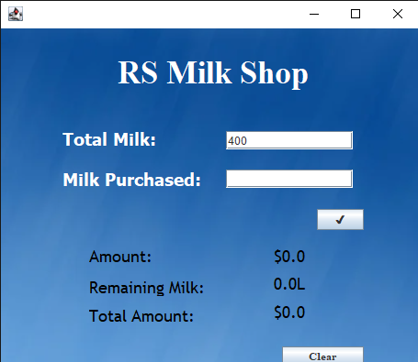

## Snap 02:

Then the costumers will buy the Required milk. The manager will input the **Milk Purchased** in the program and the program will calculate the **Amount** of required milk and **Total Amount** of all the previously purchased milks (in liters). The program will also show the **Remaining Milk** left in the shop.

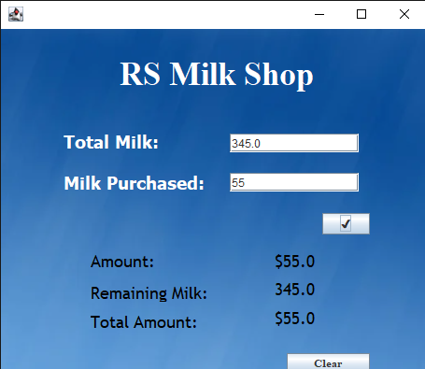

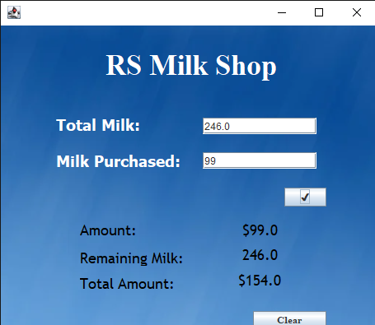

## Snap 03

When the **Required Milk** will become 0, the program will show the message dialogue box “**Milk has Ended Now!**”

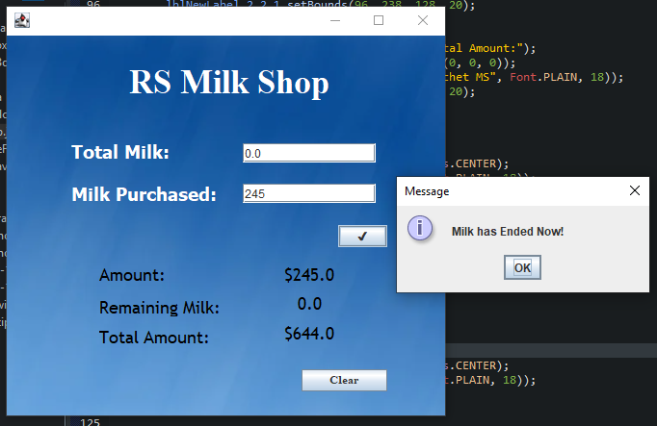

# REQUIREMENTS

## HARDWARE REQUIRED

**Printer:** to print the required documents of the project

**Compact Drive**

**Processor:** Intel(R) Core(TM) **RAM:** 512 MB or more than 512MB

**Hard Disk:** 80 GB or more than 80GB.

## SOFTWARE REQUIRED

**Operating system:** Windows 10

**Ms word,** for report writing

**Eclipse :** we have used eclipse having SWINGS files installed in it to write source code.

# CONCLUSION

This application is built such a way that it should suits for all type of Milk Distributors in future. So every effort is taken to implement this project in this Milk Distributor Office, on successful implementation in this Milk Distributor Office, we can target other Milk Distributors in the city. Milk shop management system project is a software application useful for dairy forms for managing daily activities like receiving of milk from various sources. The program application has a user-friendly interface and is easy to use. It can be accessed by milk shop managers and admin at any time in any Platform Reduces manual work and time consumption. Provides data security. Data loss and misuse of data is avoided.

We take this opportunity to thank all our lecturers (specially DR. IRFAN BHACHO) who have directly or indirectly helped our project.

We pay our respects and love to our parents and all other family

members and friends for their love and encouragement

throughout our career. Last but not the least we express our

thanks to our friends for their cooperation and support.

**We thank you Dr. Irfan Bhacho & Sir Jamsher**

**for Preparing our Future by teaching us**

**Object oriented programming**

# ACKNOWLEDGEMENTS